SpendWise: A Simple Backend Learning Project
Ideation Phase
Define the Problem Statements

Date | 08 March 2026
Team ID | SWTID-2026-7798
Project Name | SpendWise
Maximum Marks | 2 Marks

Customer Problem Statement Template:
A customer problem statement helps capture the user’s perspective when learning from a product. In the SpendWise project, it concentrates on the requirements of beginner backend learners who want to understand Node.js, Express, MongoDB, and JWT in a clear and practical manner. It highlights challenges such as getting overwhelmed by complicated projects and struggling to link different backend concepts together. By identifying these issues, the solution can remain simple, practical, and easier for students to grasp.
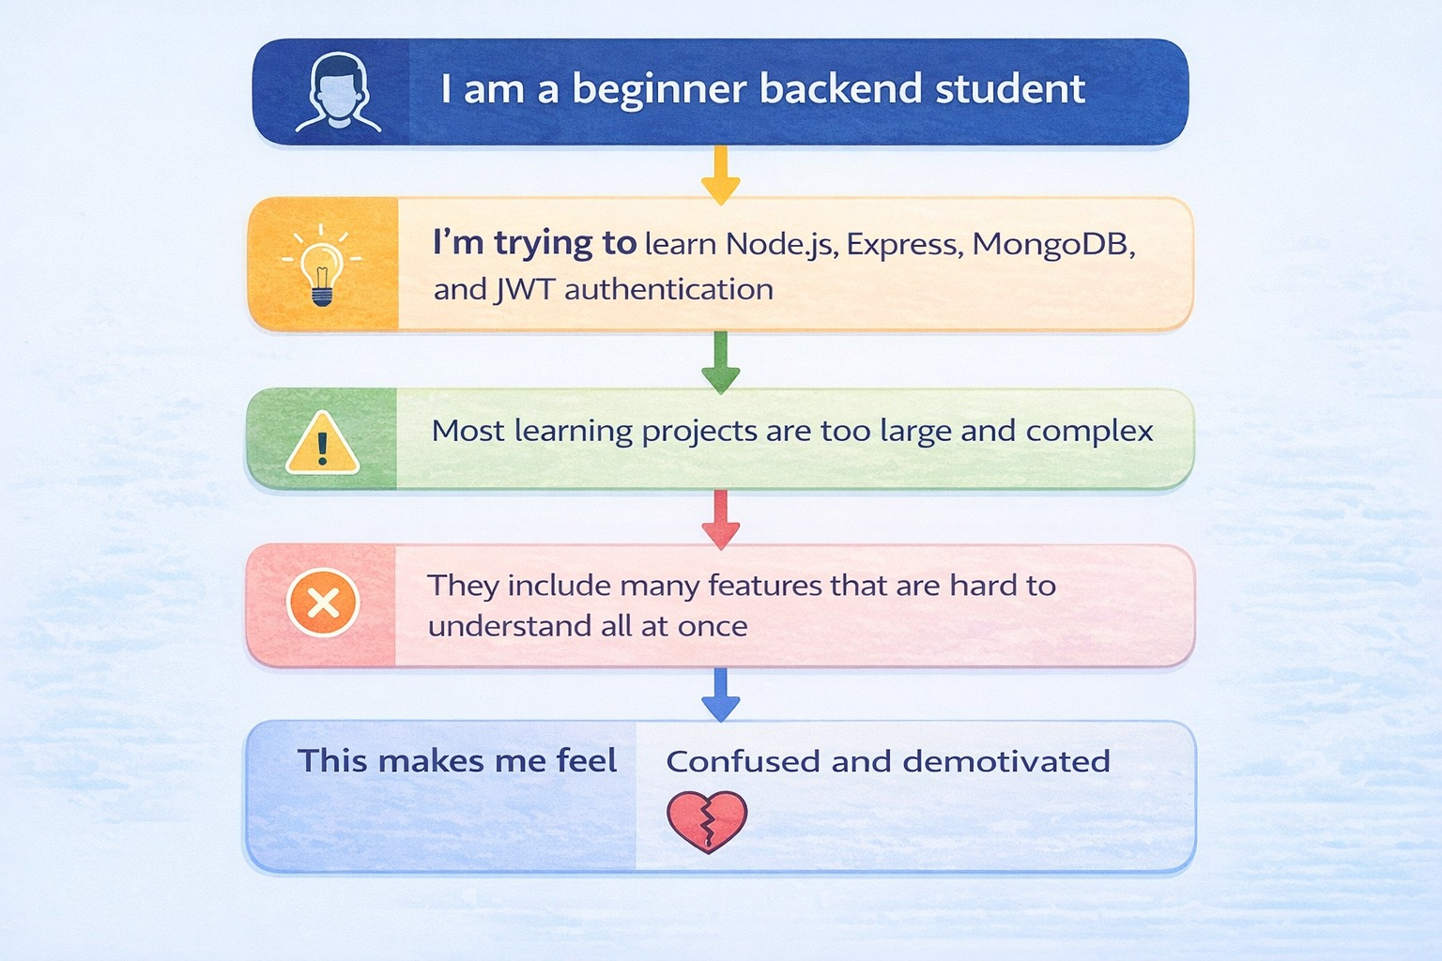

Example:
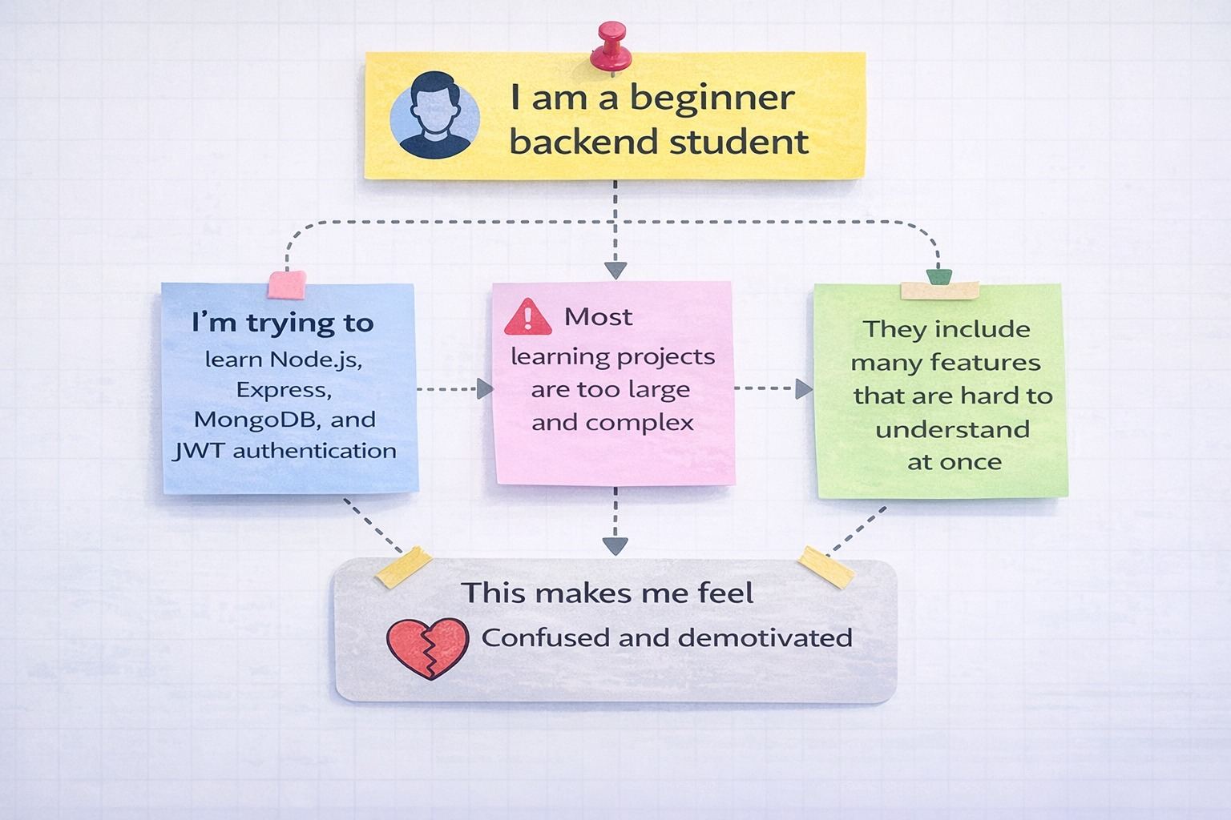

Problem Statement (PS) | I am backend student(Customer) | I’m trying to | But | Because | Which makes me feel
PS-1 | A student who is new to backend development. | Currently learning technologies like Node.js, Express, MongoDB, and JWT authentication. | Many practice projects available online are very large and complicated. | These projects contain too many features, making them difficult to understand all at once. | This situation often leads to confusion and loss of motivation.
PS-2 | A student studying in college. | Wants to create a basic backend project for learning and academic submission. | Finds it difficult to get a simple example that focuses only on CRUD operations and authentication. | Many tutorials quickly move to advanced concepts without clearly explaining the fundamentals. | Because of this, the student feels uncertain about their level of understanding.
PS-3 | A new developer who is just starting out. | Trying to integrate JWT authentication with MongoDB and backend APIs. | Frequently encountering errors related to tokens or database connections. | The process connecting login, token generation, and protected routes is confusing. | As a result, the developer feels frustrated and unable to move forward.
PS-4 | A student getting ready for a viva or job interview. | Needs to explain CRUD operations and JWT authentication using a project example. | Unable to find a clear and simple end-to-end backend project to refer to. | Most resources are either too simple or too complex, making them hard to follow. | Because of this, the student feels unprepared and nervous.

